Views & Functions Test Cases

VIEWS TEST Cases

Test Case 1 – vw_StudentCourseResults
Test Query:
SELECT * FROM vw_StudentCourseResults;
Expected Result:
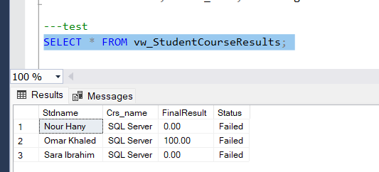
Comment:
Confirms correct aggregation of course results and pass/fail logic based on minimum degree.

Test Case 2 – vw_ExamRanking
Test Query:
SELECT * FROM vw_ExamRanking WHERE ExId = 1;
Expected Result:
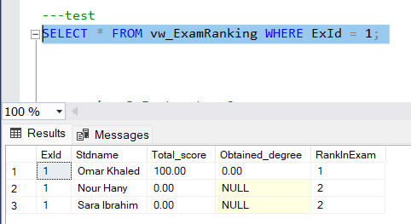
Comment:
Validates ranking logic and partitioning per exam.

Test Case 3 – vw_InstructorCourses
Test Query:
SELECT * FROM vw_InstructorCourses;
Expected Result:
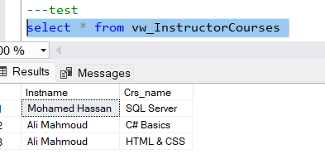
Comment:
Confirms many-to-many relationship between Instructor and Course.

Test Case 4 – vw_StudentExamDetails
Test Query:
SELECT *
FROM vw_StudentExamDetails
WHERE Stdname = 'Omar Khaled';
Expected Result:
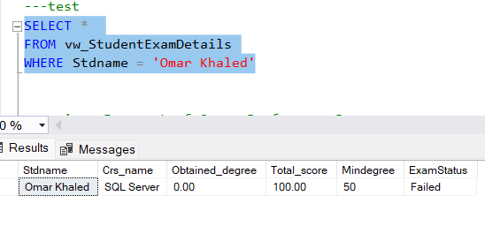
Comment:
Validates student-level detailed reporting.

Test Case 5 – vw_CoursePerformanceSummary
Test Query:
SELECT * FROM vw_CoursePerformanceSummary;
Expected Result:
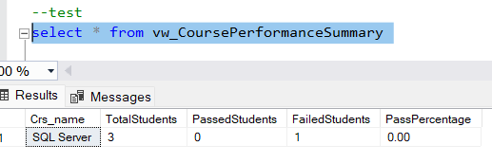
Comment:
Confirms statistical aggregation and percentage calculation.

Test Case 6 – vw_TopStudentsPerCourse
Test Query:
SELECT * FROM vw_TopStudentsPerCourse;
Expected Result:
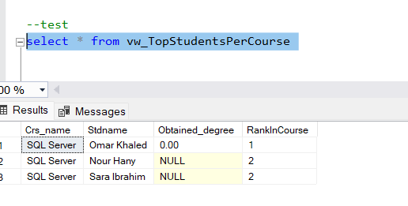
Comment:
Validates DENSE_RANK() implementation.

Test Case 7 – vw_StudentsAtRisk
Test Query:
SELECT * FROM vw_StudentsAtRisk;
Expected Result:
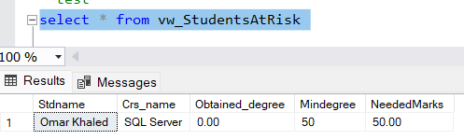
Comment:
Confirms detection of students below minimum passing degree.

Test Case 8 – vw_ExamStatistics
Test Query:
SELECT * FROM vw_ExamStatistics;
Expected Result:
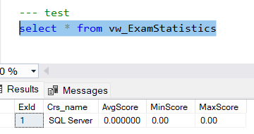
Comment:
Validates exam performance indicators.

FUNCTIONS TEST SHEETS

Test Case 9 – fn_IsAnswerCorrect
Test Query:
SELECT dbo.fn_IsAnswerCorrect(1, '1');
SELECT dbo.fn_IsAnswerCorrect(2, 'False');
SELECT dbo.fn_IsAnswerCorrect(3, 'SELECT *');
Expected Result:
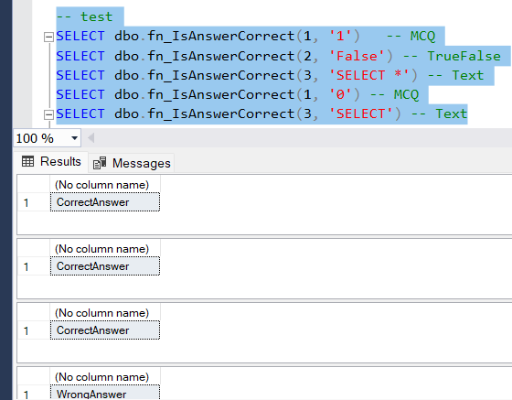
Comment:
Confirms correct validation for MCQ, True/False, and Text types.

Test Case 10 – fn_StudentTotalScore
Test Query:
SELECT dbo.fn_StudentTotalScore('Sara Ibrahim',1);
Expected Result:
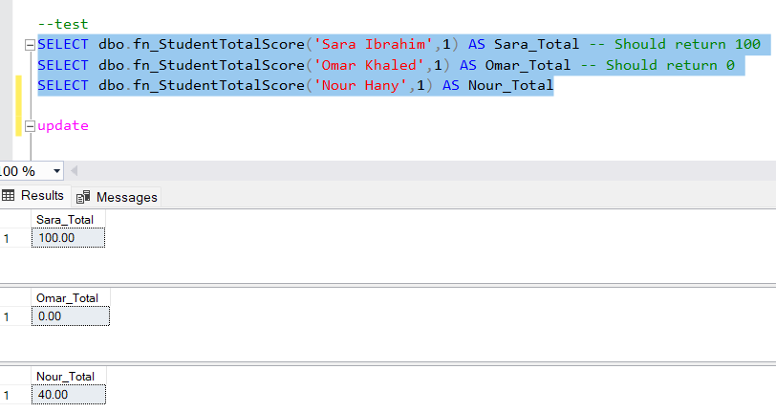
Comment:
Validates summation of grading marks per student per exam.

Test Case 11 – fn_GetExamStatus
Test Query:
SELECT dbo.fn_GetExamStatus('Database');
Expected Result:
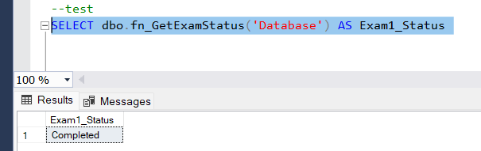
Comment:
Confirms time-based exam state detection.

Test Case 12 – fn_CalculateAge
Test Query:
SELECT Stdname, dbo.fn_CalculateAge(Birthday) FROM Student;
Expected Result:
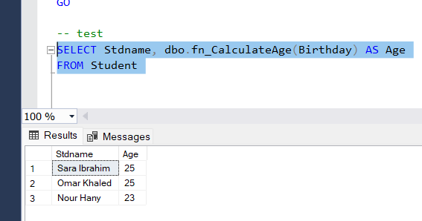
Comment:
Validates accurate age calculation logic.

Test Case 13 – fn_CourseFinalResult
Test Query:
SELECT dbo.fn_CourseFinalResult('Sara Ibrahim','SQL Server');
Expected Result:
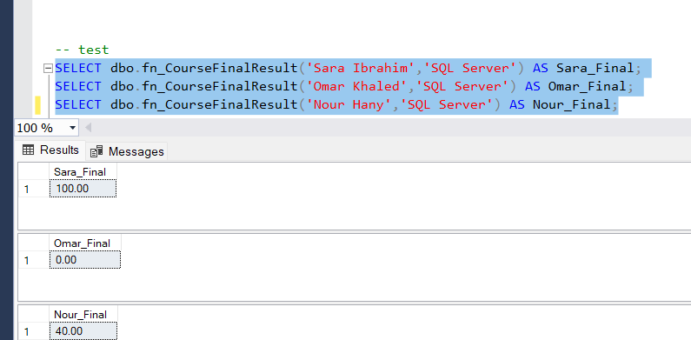
Comment:
Confirms aggregation across all related exams.

Test Case 14 – fn_IsStudentPassedCourse
Test Query:
SELECT dbo.fn_IsStudentPassedCourse('Sara Ibrahim','SQL Server');
Expected Result:
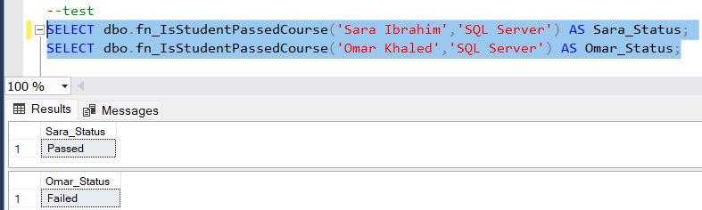
Comment:
Validates pass/fail logic using course minimum degree.

Test Case 15 – fn_GetStudentRankInExam
Test Query:
SELECT dbo.fn_GetStudentRankInExam('Omar Khaled','SQL Server');
Expected Result:
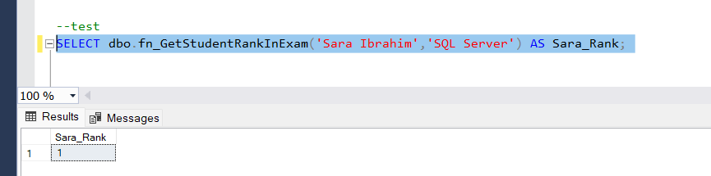
Comment:
Confirms ROW_NUMBER ranking implementation.

Test Case 16 – fn_IsExamTimeValid
Test Query:
SELECT dbo.fn_IsExamTimeValid('DataBase');
Expected Result:
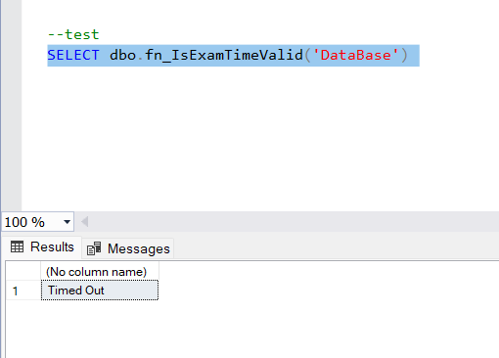
Comment:
Validates time-window access control logic.

